Do you feel ISOLATED?

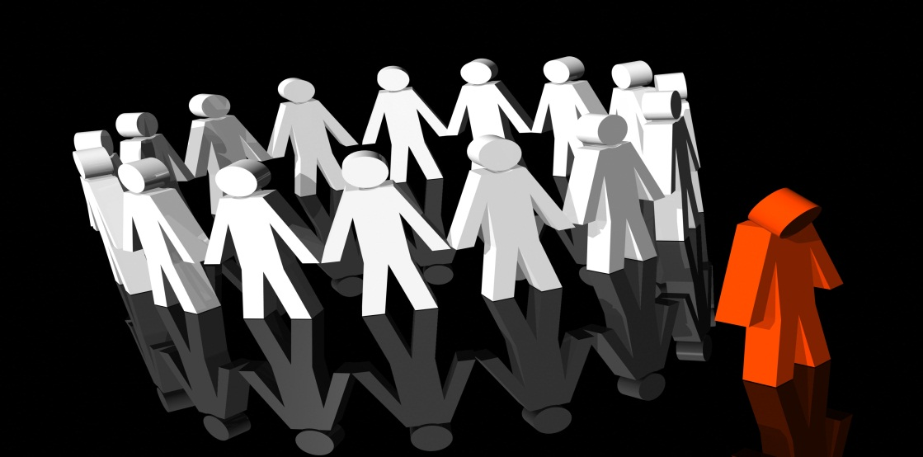
By your family, friends or community because of your disability?

Don’t worry we are here to

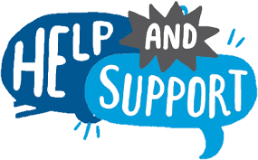
You . Join our campaign that will advocate for the right of people with disability.

